[BUXTON / MICROSOFT COLLECTION](http://research.microsoft.com/en-us/um/people/bibuxton/buxtoncollection/default.aspx)

[home](http://research.microsoft.com/en-us/um/people/bibuxton/buxtoncollection/default.aspx) | [explore](http://research.microsoft.com/en-us/um/people/bibuxton/buxtoncollection/browse.aspx) | associated narratives | [about | acknowledgments](http://research.microsoft.com/en-us/um/people/bibuxton/buxtoncollection/acknowledgements.aspx) | [contact](http://research.microsoft.com/en-us/um/people/bibuxton/buxtoncollection/contact.aspx)

**Cables Unlimited A4Tech BatteryFREE Wireless Optical Mouse Model NB-75D**

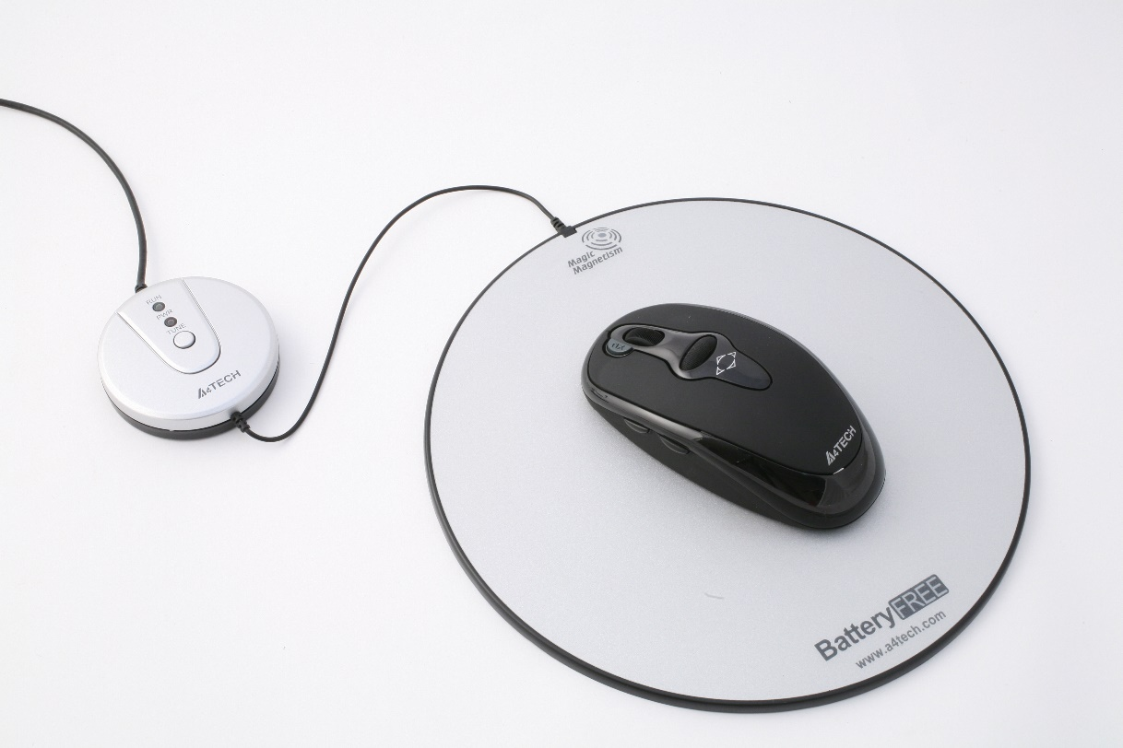

Short Description: xxxxxx

Bill Buxton’s Notes

To come

.

Device Details

Company: Cables Unlimited | Year: XXXX | Original Price (USD): XXX

Design: XXX

Degrees of Freedom: XXX

Dimensions (L x W x H): XXX x XXX x XXX (mm) Note: watch is W x D (Width is the shortest distance across the dial side of the main plate measured through the center.)

Key Words

Primary: XXX

Secondary: XXXX

{Advertisment, Ball Mouse, Book, Button, Calculator, Camera, Chord Keyboard, Computer, Cursor, Dial, e-Reader, Ergonomic, Flexible Keyboard, Foldable Keyboard, Foot Control, Game Controller, Game Machine, Gesture, Glove, Magazine, Mouse, Handheld, Handset, Head Control, Joystick, Keyboard, Keypad, Laptop, Magazine, Mini-Keyboard, Miscellaneous, MP3 Player, Multi-Touch, Music Player, Numerical Keypad, One-Handed Keyboard, Optical Mouse, PDA, Pedal, Pen Computer, Phone, Protective Case, Puck, Reference Object, Remote Control, Roller, Reskin, Slate, Slider, Sound Recorder, Stereoscope, Stylus, Tablet, Thermostat, Touch Pad, Theme, Touch Screen, Touch Tablet, Toy, Trackball, VR, Virtual Reality, Watch, Wearable, Wheel}

Links

* <http://www.ubergizmo.com/2007/11/a4tech-battery-free-wireless-mouse/>
* [A4Tech BatteryFREE Wireless Optical Mouse User's Guide Model: NB-75D](https://microsoft-my.sharepoint.com/personal/bibuxton_microsoft_com/Documents/Buxton%20Collection/Collection/To%20Shoot/A4_Tech_NB-75D%20Mouse/NB75D_Mouse_Manual.pdf)
* <http://a4tech.com/product.asp?cid=142&scid=122&id=342>
* <NB75D_Mouse_Manual.pdf>
* powerpoint
* Vimeo video link
* XXX

|  |  |  |
| --- | --- | --- |
| **Image** | **File Name** | **Caption** |
| :NB75D_IMG_0682.JPG | NB75D\_IMG\_0682.JPG |  |
| :NB75D_IMG_0666.JPG | NB75D\_IMG\_0666.JPG |  |
| :NB75D_IMG_0671.JPG | NB75D\_IMG\_0671.JPG |  |
| :NB75D_IMG_0672.JPG | NB75D\_IMG\_0672.JPG |  |
| :NB75D_IMG_0673.JPG | NB75D\_IMG\_0673.JPG |  |
| :NB75D_IMG_0676.JPG | NB75D\_IMG\_0676.JPG |  |
| :NB75D_IMG_0679.JPG | NB75D\_IMG\_0679.JPG |  |
| :NB75D_IMG_2016.JPG | NB75D\_IMG\_2016.JPG |  |
| [:NB75D_Mouse_Manual.jpg](NB75D_Mouse_Manual.pdf) | NB75D\_Mouse\_Manual.jpg | (click on image to access full document) |
|  |  |  |
|  |  | See the link below to access the pdf containing the full document. |

**WORK NOTES:**

* year, price, DOF
* <http://a4tech.com/product.asp?cid=142&scid=122&id=342>